貨品編號 | 規格(T:厚度,W:展開寬) | 圖片
S-12-4-O | 1.2T*65W*104L*孔4.5mm | 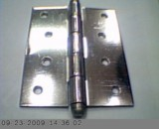
S-05-1-O | 0.5T*17W*25L*孔2.8mm | 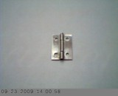
S-05-15-O | 0.5T*26W*37L*孔3.5mm | 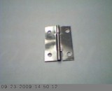
S-12-2-O | 1.2T*35W*53.5L*孔3.4mm | 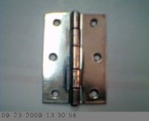
S-12-3-O | 1.2T*47W*80L*孔4mm | 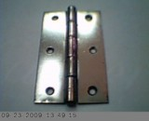
S-12-4-O | 1.2T*65W*104L*孔4.5mm | 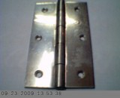
貨品編號 | 規格(T:厚度,W:展開寬) | 圖片
S-12-25-O | 1.2T*42W*66L*孔4mm | 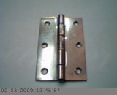
SS-1-15 | 1T*36W*62L | 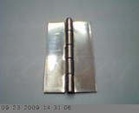
SS-2-2-O | 6T*50W*50L*孔6.3mm | 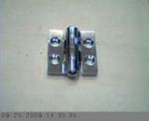
SS-2-3-O | 2T*41W*73L*孔4.5mm | 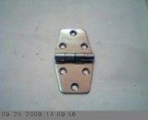
SS-2-25 | 2T*51W*67L | 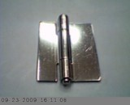
SS-2-25-O | 2T*51W*67L*孔8mm | 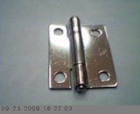
貨品編號 | 規格(T:厚度,W:展開寬) | 圖片
SS-3-4-O | 3T*60W*90L*孔6mm | 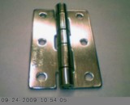
SS-12-2 | 1.2T*36W*48L | 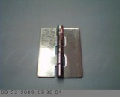
SS-14-1-O | 1.4T*32W*28L*孔3.3mm | 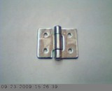
SS-15-2 | 1.5T*35W*50L | 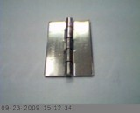
SS-15-2-O | 1.5T*35W*50L*孔4.3mm | 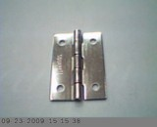
SS-A-3-35 | 3T*50W*85L | 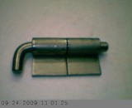
貨品編號 | 規格(T:厚度,W:展開寬) | 圖片
SS-SO-25-2 | 2.5T*72W*55L | 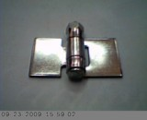
SS-SO-25-4 | 2.5T*78W*100L | 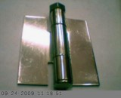
SS-SO-25-55-O | 2.5T*55W*137L*孔11mm | 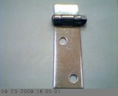
SS-T-2-2 | 2T*44W*52L | 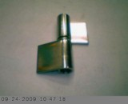
SS-T-2-3 | 2T*53W*76L | 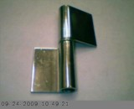
SS-T-2-4 | 2.5T*53W*98L | 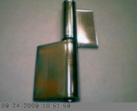
貨品編號 | 規格(T:厚度,W:展開寬) | 圖片
SS-T-2-25-O | 2T*41W*62L*孔5mm | 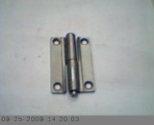
SS-T-2-45 | 2T*47W*115L | 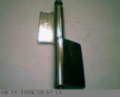
SS-T-3-5 | 3T*102W*130L | 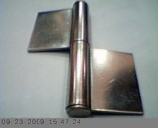
SS-T-3-5-O | 3T*102W*130L*孔6mm | 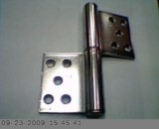
SS-T-3-45 | 3T*84W*118L | 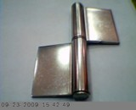
SS-T-3-45-O | 3T*84W*118L*孔5.5mm | 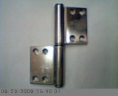
貨品編號 | 規格(T:厚度,W:展開寬) | 圖片
SS-T-4-6-O | 4T*102W*158L*孔6mm | 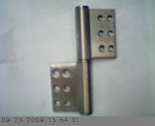
SS-T-15-25 | 1.5T*36W*67L | 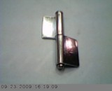
X-2-25 | 2T*52W*62L | 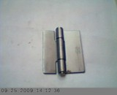
X-2-25-O | 2T*52W*62L*孔8mm | 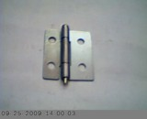
X-05-15 | 0.5T*26W*35L | 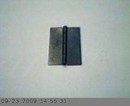
X-08-15-O | 0.8T*26W*38L*孔3.5mm | 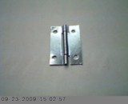
貨品編號 | 規格(T:厚度,W:展開寬) | 圖片
X-14-15-O | 1.4T*32W*38L*孔4mm | 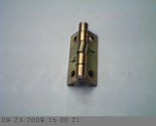
X-15-2-O | 1.5T*41W*53L*孔4mm | 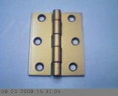
X-18-4-O | 1.8T*73W*103L*孔5mm | 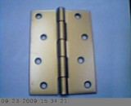
X-SO-25-55-O | 2.5T*55W*135L*孔10mm | 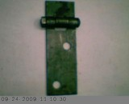
X-T-12-15 | 1.2T*36W*38L | 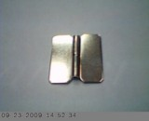
X-T-16-2 | 1.6T*20W*43L | 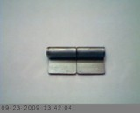
貨品編號 | 規格(T:厚度,W:展開寬) | 圖片
X-T-25-2 | 2.5T*45W*60L | 